**PRACTICAL NO 2**

Assigning Address

IPv6 addresses the main problem of IPv4, i.e., the exhaustion of addresses to connect computers or host in a network. IPv6 has a very large address space and consists of 128 bits as compared to 32 bits in IPv4. Therefore, it is now possible to support 2^128 unique IP addresses, a substantial increase in number of computers that can be addressed with the help of IPv6 addressing scheme.

In addition, this addressing scheme will also eliminate the need of NAT (network address translation) that causes several networking problems (such as hiding multiple hosts behind pool of IP addresses) in end-to-end nature of the Internet.

Stateless Auto-reconfiguration of Hosts feature allows IPv6 host to configure automatically when connected to a routed IPv6 network. IPv6 implements network-layer encryption and authentication via IPsec.

It supports two types of configuration:

1)Stateful Configuration

This type of configuration requires a certain level of human intervention because it needs a Dynamic Host Configuration Protocol for IPv6 (DHCPv6) server for the installation and administration of the nodes.

The DHCPv6 server keeps a list of nodes to which it supplies configuration information.

It also maintains state information so the server knows how long each address is in use, and when it might be available for reassignment.

2)Stateless configuration

Stateless Auto Configuration is an important feature offered by the IPv6 protocol.

It allows the various devices attached to an IPv6 network to connect to the Internet using the Stateless Auto Configuration without requiring any intermediate IP support in the form of a Dynamic Host Configuration Protocol (DHCP) server.

A DHCP server holds a pool of IP addresses that are dynamically assigned for a specified amount of time to the requesting node in a Local Area Network (LAN).

**AIM: CONNECT PC WITH SWITCH AND ROUTER. ASSIGN ADDRESS USING AUTOCONFIG**

**CODE and OUTPUT:**

Step 1: Design the following topology using a router, switch and 6 PC’s.

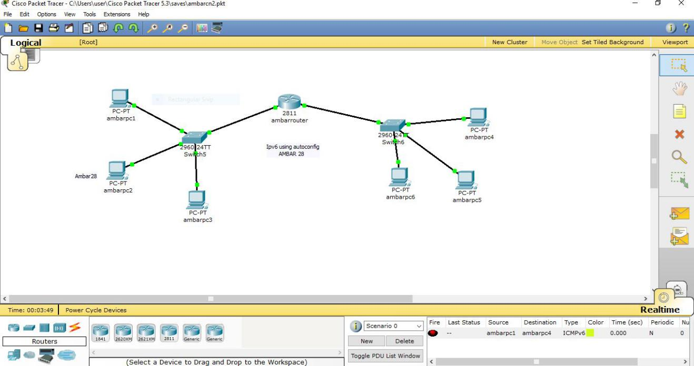

Step 2: Click on the PC’s and assign IP address to each PC.

Step 3: Click on the router and go to CLI and type the following commands.

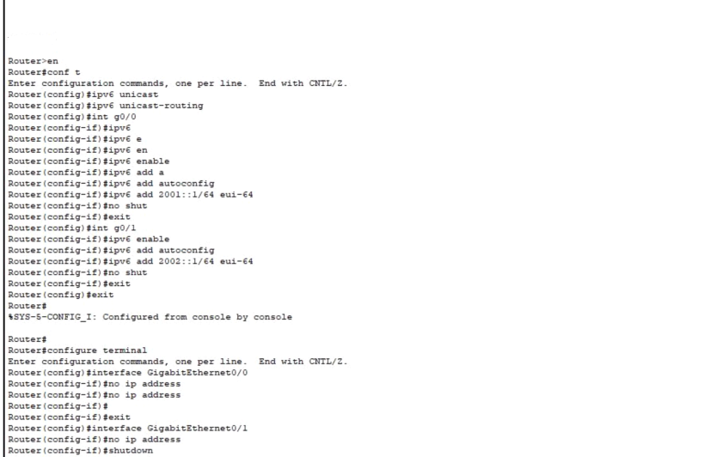

Step 4: After executing the above commands, go to each PC’s config mode. Click on AutoConfig. Changes as shown below will be seen in all the PC’s.









**AIM: Subnetting / notation (Theory)**

**DESCRIPTION:**

When a bigger network is divided into smaller networks, in order to maintain security, then that is

known as Subnetting. So, maintenance is easier for smaller networks.

Divide the network into two parts:

IP Address = 193.1.2.0

It is a class C IP so, there are 24 bits in the Network ID part and 8 bits in the Host ID part.

Network ID Part: 193.1.2

Host ID Part: 00000000

To Divide a network into two parts, we need to choose one bit for each subnet from the Host ID

part.

Example:

• 193.1.2.00000000

• 193.1.2.10000000

Subnet 1:

Range: 193.1.2.00000000 – 193.1.2.01111111

Subnet 2:

Range: 193.1.2.10000000 – 193.1.2.11111111

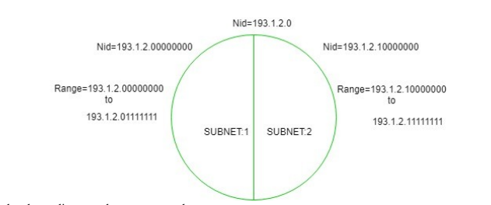

In the above diagram, there are two subnets.

1. To divide a network into four (22) parts we need to choose two bits from host id part for

each subnet i.e, (00, 01, 10, 11).

2. To divide a network into eight (23) parts we need to choose three bits from host id part for

each subnet i.e, (000, 001, 010, 011, 100, 101, 110, 111) and so on.

**AIM: Configure MAC address**

**DESCRIPTION:**

Topology:

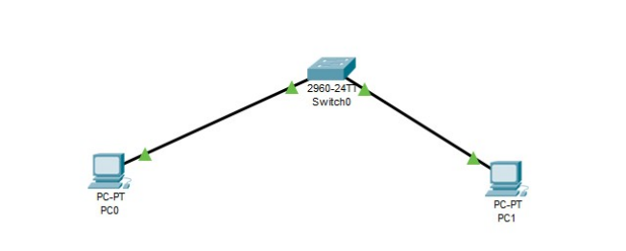

Command to Configure MAC address:

